**TABLE OF CONTENT**

|  |  |  |
| --- | --- | --- |
| SL.No. | CONTENT | PAGE NO. |
| 01 | **Problem Statement** | 02 |
| 02 | **Introduction**  a. Background  a.  b. Challenges | 03 |
| 03 | **Scripting/ Programming Language**   * 1. HTML   2. CSS   3. JS | 04-07 |
| 04 | **Proposed Website**   * 1. Flowchart   2. Key highlights   3. Source Code   4. Screenshot | 08-31 |
| 05 | **Conclusion** | 32 |
| 06 | **Future work** | 33-34 |
| 07 | **References** | 35 |

**Problem Statement**

Odisha, with its rich cultural history, stunning landscapes, and diverse tourist attractions, is an underexplored gem in the tourism sector of India. However, many potential visitors are unaware of the hidden gems the state has to offer. There is a need for an accessible and informative digital platform that highlights the top tourist destinations in Odisha in an engaging and interactive way.

The primary problem is the lack of a user-friendly and visually attractive web platform that provides comprehensive information about Odisha's tourist spots. Visitors often struggle to find consolidated and interactive content about the state’s key attractions, which may result in missed opportunities for travel enthusiasts.

**Key Challenges:**

1. **Lack of Interactive and Accessible Platforms**: Existing digital resources about Odisha’s tourism are often static and not optimized for mobile or desktop users, leading to a suboptimal user experience.
2. **Lack of Consolidated Information**: Tourists have difficulty finding a one-stop platform that integrates detailed descriptions, images, and interactive elements (like maps, galleries, or event schedules) for each tourist destination.
3. **Navigation and User Experience Issues**: Most websites lack smooth navigation, are poorly structured, and do not provide an intuitive way for users to explore multiple locations quickly.

**Objective:**

To develop an interactive and informative website that:

1. Uses **HTML** for structuring content related to each of Odisha’s tourist spots.
2. Implements **CSS** for an aesthetically pleasing design, ensuring the site is responsive and visually appealing across various devices.
3. Integrates **JavaScript** for enhanced interactivity, such as smooth scrolling, image sliders, dynamic content loading, and easy navigation.

This case study will demonstrate how these web development technologies can be used to create a user-friendly and engaging digital platform for promoting tourism in Odisha, ultimately helping increase awareness and encouraging more tourists to explore the state's attractions.

**Introduction**

This case study aims to explore the top 7 tourist places in Odisha, showcasing the cultural, historical, and natural significance of each. The objective is to present these destinations through an interactive and visually appealing website using HTML, CSS, and JavaScript. This website will serve as a guide for potential travelers, offering not only detailed descriptions and images but also easy navigation to enhance the user experience.

**A. Background**

Odisha, a state on the eastern coast of India, is rich in cultural heritage, history, and natural beauty. Known for its ancient temples, picturesque beaches, tranquil lakes, and wildlife sanctuaries, Odisha offers diverse experiences for travelers. Among its key attractions are the Puri Jagannath Temple, Konark Sun Temple, Chilika Lake, and the bustling city of Bhubaneswar. Despite its significant tourism potential, Odisha remains underexplored by many domestic and international travelers.

The tourism sector plays a crucial role in the state’s economy, but the lack of an effective digital platform to showcase its attractions makes it difficult for potential tourists to access comprehensive information about these destinations. With the rise of internet usage and the increasing dependence on digital platforms for travel planning, there is a growing need for a dedicated, interactive, and informative website that can effectively promote Odisha’s tourism spots.

This case study aims to address this need by creating a digital platform using HTML, CSS, and JavaScript, designed to present Odisha’s top 7 tourist places. The website will offer a detailed description, stunning visuals, and an interactive interface to help tourists explore these attractions more easily.

**B. Challenges**

1. **Lack of Comprehensive Digital Representation**: Although there are several online resources available for Odisha’s tourism, they are often fragmented and lack a comprehensive, centralized digital resource. Visitors may struggle to find consolidated, well-organized information about the state’s tourist attractions in one place.
2. **Poor User Experience on Existing Platforms**: Many existing websites or apps that showcase Odisha’s tourist spots suffer from poor design and user experience issues. These platforms are often cluttered, difficult to navigate, and not mobile-friendly, leading to a frustrating experience for users looking for travel information.
3. **Insufficient Interactivity**: Traditional websites for tourism information often fail to engage users interactively. They do not include features like interactive maps, smooth scrolling, or dynamic galleries that could enhance the user experience. Such interactive features can make a website more appealing and informative.
4. **Outdated or Limited Content**: Many tourism websites do not provide updated content about events, festivals, and other time-sensitive information. This leaves visitors with incomplete or outdated details, affecting their travel decisions.

**Scripting/ Programming Language**

1. **HTML (Hypertext Markup Language)**

**Role in the Project**:  
HTML is the backbone of the website, used to structure and organize the content. It provides the basic layout for the webpage, allowing different sections to be marked up correctly. HTML elements are used to define headings, paragraphs, images, links, and other content.

* **Purpose in the Case Study**:  
  HTML will be used to:
* **Structure the Webpage**: HTML is essential for creating a well-organized structure for the webpage. Using semantic elements like <header>, <nav>, <section>, <article>, and <footer>, the content can be divided into meaningful sections. This structure improves readability and helps search engines understand the content.
* **Headings, Subheadings, and Paragraphs**: HTML tags like <h1>, <h2>, <h3>, and <p> are used to create a hierarchy of headings and subheadings, which helps in presenting detailed information about each tourist spot. This hierarchical structure makes the content easy to navigate and comprehend for users.
* **Including Images**: The <img> tag is used to embed images of each tourist location. Proper use of attributes like alt (alternative text) ensures that the images are accessible to users with disabilities and improve the site's SEO. High-quality images can visually captivate users and enhance their understanding of the tourist spots.
* **Navigation Links**: HTML enables the creation of a navigation menu using the <nav> and <a> tags. This menu provides links to different sections of the website, allowing users to easily navigate between various tourist spots, information sections, and additional resources.
* **Embedding Multimedia**: HTML allows for embedding maps using the <iframe> tag, which can display interactive maps of Odisha with markers on key tourist destinations. Additionally, <video> and <audio> tags can be used to include multimedia content like promotional videos or audio guides about the tourist spots.
* **Contact Details and Forms**: Using HTML forms (<form>, <input>, <textarea>, <button>) to collect user feedback, inquiries, or booking requests. This functionality is crucial for engaging with users and providing them with a means to contact the tourism department or service providers.
* **Textual Content and Metadata**: HTML is used to present textual content such as the history, importance, and visitor information of each tourist spot. It also allows the inclusion of metadata through <meta> tags, which can help improve the website’s SEO by providing search engines with relevant information about the webpage content.
* **Accessibility Features**: HTML elements support various attributes and tags that enhance accessibility, such as aria-* attributes for better screen reader support. This ensures that the website is usable by a wider audience, including people with disabilities

1. **CSS (Cascading Style Sheets)**

**Role in the Project**:  
CSS is used for the visual styling and layout of the webpage. It determines how the HTML elements appear on the screen, enhancing the user experience by making the website more attractive, responsive, and functional.

* **Purpose in the Case Study**:  
  CSS will be employed to:
* **Styling the Navigation Menu**: CSS will be used to style the navigation menu, ensuring it is clear and easy to use. This includes defining the layout, colors, fonts, and hover effects. A well-styled navigation menu improves usability by making it intuitive for users to find and access different sections of the case study.
* **Defining Layouts**: CSS is essential for defining the layout of images, text, and other content. Using techniques like flexbox and grid layout, CSS can create a responsive and visually appealing design that adjusts to different screen sizes and orientations. This ensures that content is displayed in an organized and aesthetically pleasing manner.
* **Responsive Design**: CSS media queries allow the website to be responsive, ensuring it looks good on both desktop and mobile devices. By adjusting the layout, font sizes, and image scaling based on the screen size, CSS ensures that users have a seamless experience regardless of the device they are using.
* **Color Schemes and Fonts**: Applying consistent color schemes and font styles is crucial for aesthetics. CSS allows for customization of colors, backgrounds, borders, and typography, reflecting the cultural and vibrant spirit of Odisha. Using web fonts and custom font families, the text can be made more readable and visually appealing.
* **Animations and Transitions**: CSS animations and transitions can be used to add dynamic elements to the webpage. For example, fading effects on images, smooth transitions for navigation links, and interactive elements that respond to user actions can make the site more engaging.
* **Hover Effects and Interactivity**: CSS can define hover effects for buttons, links, and images, enhancing interactivity. These effects provide visual feedback to users, making the website feel more responsive and interactive.
* **Consistent Styling**: CSS ensures a uniform look and feel across all pages. By defining global styles in a stylesheet, consistency is maintained throughout the website, contributing to a professional and cohesive design.
* **Customizing Forms**: CSS is used to style forms and input elements, making them more visually appealing and user-friendly. This includes styling form fields, buttons, and validation messages to ensure they align with the overall design of the website.
* **Backgrounds and Patterns**: CSS allows for the use of background images, gradients, and patterns to enhance the visual appeal of the website. This can be used to create visually striking sections that capture the essence of Odisha's landscapes and cultural heritage.
* **Shadow and Depth Effects**: Applying box shadows and text shadows can add depth to elements, making the design more engaging. These effects can be used to highlight important content and create a more dynamic visual experience.

1. **JavaScript (JS)**

**Role in the Project**:  
JavaScript is used to add interactivity to the website. It allows the webpage to respond to user actions without reloading the page, providing a dynamic user experience.

* **Purpose in the Case Study**:  
   JavaScript will be applied to:
* **Enable Smooth Scrolling**: JavaScript can be used to implement smooth scrolling for easy navigation between sections. By capturing click events on navigation links and smoothly scrolling to the corresponding section, the user experience becomes more fluid and enjoyable, reducing the jarring effect of instant jumps to different parts of the page.
* **Interactive Image Sliders or Galleries**: JavaScript is essential for creating interactive image sliders or galleries. These allow tourists to view images of the attractions in a dynamic and engaging way. Users can click through images, view slideshows, and even zoom in on pictures. This interactivity can be achieved using JavaScript libraries or custom scripts that handle image transitions and user interactions.
* **Form Validation**: Implementing form validation is crucial for ensuring that contact or booking forms are correctly filled out before submission. JavaScript can validate inputs in real-time, checking for required fields, correct formats (e.g., email addresses, phone numbers), and providing instant feedback to users. This reduces errors and enhances user experience by guiding users to fill out forms correctly.
* **Event Listeners for Interactive Elements**: Adding event listeners for interactive elements like buttons or links is a key application of JavaScript. Event listeners allow the webpage to respond to user actions, such as clicks, hovers, or form submissions, ensuring a seamless experience. For instance, JavaScript can be used to display additional information when a user clicks a button, or to highlight a section when a user hovers over it.
* **Dynamic Content Loading**: JavaScript can dynamically load content without requiring a full page reload. This can be used to fetch and display additional information about tourist spots from a server or database, enhancing the user experience by providing up-to-date and relevant information without interrupting the browsing flow.
* **Interactive Maps**: JavaScript can integrate interactive maps using APIs like Google Maps. These maps can display markers on key tourist destinations, allow users to zoom in and out, and provide additional information when markers are clicked. This functionality enhances the geographic context and helps users visualize the locations of the attractions.
* **Animations and Effects**: JavaScript can create animations and effects that make the website more engaging. For example, fade-in effects for images and text, slide-in menus, or animated transitions between sections can capture user attention and make the browsing experience more enjoyable.
* **User Interaction and Feedback**: JavaScript can handle various user interactions and provide immediate feedback. For example, it can display confirmation messages when a form is submitted, show loading indicators while content is being fetched, or provide error messages if something goes wrong. This level of interaction makes the website feel more responsive and user-centric.
* **Custom Functionality**: JavaScript allows for the implementation of custom functionality tailored to the needs of the case study. This can include features like filtering content based on user preferences, sorting lists of tourist spots by popularity or distance, or providing interactive timelines of historical events related to the attractions.
* **Integration with APIs and External Services**: JavaScript can interact with various APIs and external services to enhance the website’s functionality. For instance, it can retrieve weather information for each tourist spot, display live social media feeds related to Odisha tourism, or fetch and display reviews from travel websites.

**Proposed Website**

* **Flowchart**
* The flowchart outlines the general structure and workflow of the website, from loading the page to interacting with the user. Below is a textual description of how the flowchart would be structured.

----------------------------------------------------------------------------------------------------------------------------------

1. **Start**
   * The process begins when a user visits the website.
2. **Load HTML Content**
   * The browser loads the main HTML content, including the structure (header, sections, footer).
3. **Render Navigation Menu**
   * The menu (list of tourist spots) is displayed at the top.
   * User can click on any tourist spot (e.g., Puri Jagannath Temple, Puri Beach, etc.) to navigate.
4. **Display Tourist Spot Information**
   * When a user clicks on a tourist spot link:
     + The corresponding section of the page (about the spot) is displayed.
     + Details such as description, images, history, etc., are loaded.
   * The layout adjusts according to the styles defined in CSS.
5. **Responsive Design Adjustment (CSS)**
   * The page layout adapts to screen size (responsive design).
   * On mobile screens, elements such as images and text resize to fit.
6. **Image Interactivity (JavaScript)**
   * Images can be dynamically resized or zoomed in based on user interaction (e.g., clicking an image for a larger view).
   * A gallery or image slider could be implemented using JavaScript for dynamic content.
7. **Smooth Scrolling**
   * JavaScript is used to enable smooth scrolling when a user clicks on a link in the navigation menu.
   * The page smoothly scrolls to the relevant section without reloading.
8. **Events and Actions**
   * JavaScript handles user interaction, such as:
     + Displaying pop-ups or modal windows with additional details (e.g., event details at a specific tourist spot).
     + Showing hidden sections (e.g., special offers, upcoming events, or festivals).
9. **End**
   * The process continues as long as the user navigates through the website.
   * Once the user finishes interacting, they can exit the website.

* **Flowchart Representation (Textual)**

Start

Load HTML Content → Render Navigation Menu → User Clicks on a Tourist Spot

Display Tourist Spot Info (Text & Image) ← Responsive Design (CSS)

Image Interactivity (JS) → Gallery or Slider (JS)

Smooth Scrolling (JS) → Display Dynamic Content (JS) → User Actions (Pop-ups/Events)

End

* This flowchart represents the sequential steps taken by the website and how HTML, CSS, and JavaScript work together to create a dynamic and interactive user experience.
* **Key Highlights**

1. **Interactive Web Design**:
   * The website is designed to provide an engaging and user-friendly interface with smooth navigation and interactivity, making it easier for users to explore Odisha's top tourist spots.
2. **Detailed Tourist Spot Information**:
   * Each tourist destination is described in detail, including history, significance, and major attractions, supported by images and videos for a more immersive experience.
3. **Responsive Design**:
   * The website is optimized for different screen sizes, ensuring it provides an excellent user experience on both desktop and mobile devices, adapting automatically to the screen's resolution.
4. **Dynamic Content Loading**:
   * JavaScript is used to dynamically load content such as galleries, event details, and upcoming festivals, ensuring that the website stays current and relevant for users.
5. **Smooth Scrolling and Navigation**:
   * The use of smooth scrolling enhances navigation, allowing users to move between sections without page reloads. It enables a seamless browsing experience.
6. **Image and Media Integration**:
   * High-quality images and media are integrated to give visitors a visual experience of each location. JavaScript is used to create interactive galleries or sliders for better visual engagement.
7. **Enhanced User Interactivity**:
   * JavaScript enhances interactivity through elements like pop-ups, modals, and event listeners that respond to user actions, such as clicking on images or links, making the website more engaging.
8. **Cross-Platform Compatibility**:
   * The website works efficiently across different devices and browsers, ensuring that users can access information regardless of their platform, whether it’s on a smartphone, tablet, or desktop.
9. **Attractive UI with CSS Styling**:
   * Aesthetic elements such as fonts, colors, and layout design are handled through CSS, creating an appealing and professional visual style that is consistent across the website.
10. **Promotion of Odisha Tourism**:

* By showcasing Odisha's top tourist destinations in an informative and visually appealing way, the website serves as an effective digital platform to promote the state's tourism sector to a global audience.

1. **Interactive Maps**:

* Integrating interactive maps allows users to explore tourist spots geographically. Clicking on map markers provides detailed information and images of each location, enhancing the exploratory experience.

1. **User Reviews and Ratings**:

* Implementing a section for user reviews and ratings helps future visitors make informed decisions and enhances credibility by showcasing authentic feedback from past tourists.

1. **Social Media Integration**:

* Integrating social media feeds and sharing buttons allows users to share their experiences and the website's content, promoting Odisha's tourist spots through user-generated content.

1. **SEO Optimization**:

* The website is designed with SEO best practices to improve search engine rankings, making it easier for users to find information about Odisha's tourist destinations.

1. **Accessibility Features**:

* Ensuring the website is accessible to users with disabilities by implementing features such as screen reader compatibility, keyboard navigation, and descriptive alt texts for images.

1. **Event Calendar**:

* Including an interactive event calendar allows users to view upcoming festivals, cultural events, and important dates, helping them plan their visits accordingly.

1. **Integration with Booking Services**:

* Providing links or integration with booking services for accommodations, tours, and transportation facilitates a complete planning experience for tourists visiting Odisha.
* **Source Code :-**
* **mainpage .html**

**<html>**

**<head>**

**<title>Tourist Places in Odisha</title>**

**<link rel="stylesheet" href="style.css">**

**</head>**

**<body>**

**<header>**

**<h1>Tourist Places in Odisha</h1>**

**<br>**

**<nav>**

**<ul>**

**<li><a href="#puri">Puri Jagannath Temple</a></li>**

**<li><a href="#puri-beach">Puri Beach</a></li>**

**<li><a href="#konark">Konark</a></li>**

**<li><a href="#koraput">Koraput</a></li>**

**<li><a href="#bhubneswar">Bhubaneswar</a></li>**

**<li><a href="#chilika">Chilika Lake</a></li>**

**<li><a href="#simlipal">Simlipal National Park</a></li>**

**</ul>**

**</nav>**

**</header>**

**<h2 align="center">Top 7 Tourist Places in Odisha </h2>**

**<section id="puri">**

**<h2>Puri Jagannath Temple</h2>**

**<img src="Photos/jagnat temple 2.jpeg" alt="Puri Jagannath Temple">**

**<img src="Photos/jagnath temple.jpg" alt="Puri Jagannath Temple">**

**<p>The Puri Jagannath Temple is one of the Char Dham pilgrimage sites for Hindus. Located in Puri,**

**it is dedicated to Lord Jagannath and attracts millions of devotees, especially during the famous**

**Rath Yatra. Known for its grand architecture and spiritual significance, it is an iconic landmark**

**in Odisha.</p><br>**

**<p><a href="puri jaganath temple.html">Click Here for more details</a></p>**

**</section>**

**<section id="puri-beach">**

**<h2>Puri Beach</h2>**

**<img src="Photos/puri beach.jpg" alt="Puri Beach">**

**<img src="Photos/puri_beach 2.jpg" alt="Puri Beach">**

**<p>Puri Beach, with its golden sands and clear waters, is a serene retreat. It is famous for religious significance,**

**especially during the Rath Yatra, and offers a perfect blend of spirituality and relaxation. Visitors can enjoy**

**beach festivals and water activities.</p><br>**

**<p><a href="puri beach.html">Click Here for more details</a></p>**

**</section>**

**<section id="konark">**

**<h2>Konark Sun Temple</h2>**

**<img src="Photos/konark 2.jpg" alt="Konark Sun Temple">**

**<img src="Photos/konark.jpeg" alt="Konark Sun Temple">**

**<p>The Konark Sun Temple, a UNESCO World Heritage site, is renowned for its magnificent chariot-shaped structure.**

**Built in the 13th century, it is dedicated to the Sun God and showcases remarkable Kalinga architecture.**

**The temple’s intricacy and grandeur make it an architectural marvel.</p><br>**

**<p><a href="konark.html">Click Here for more details</a></p>**

**</section>**

**<section id="koraput">**

**<h2>Koraput</h2>**

**<img src="Photos/koraput.jpeg" alt="Koraput">**

**<img src="Photos/koraput 2.jpeg" alt="Koraput">**

**<p>Nestled in the lush green hills of southern Odisha, Koraput is known for its picturesque landscapes,**

**waterfalls, and tribal culture. The area is famous for Duduma Falls, the serene atmosphere, and its**

**natural beauty, making it a tranquil destination for nature lovers.</p><br>**

**<p><a href="koraput.html">Click Here for more details</a></p>**

**</section>**

**<section id="bhubneswar">**

**<h2>Bhubaneswar</h2>**

**<img src="Photos/bhubneshwar.jpeg" alt="Bhubaneswar">**

**<img src="Photos/bhubneshwar 2.jpeg" alt="Bhubaneswar">**

**<p>Bhubaneswar, the capital of Odisha, is known for its ancient temples, earning the title "Temple City of**

**India." With its rich heritage, Bhubaneswar is a blend of traditional architecture and modern urban**

**development, featuring prominent temples like Lingaraj Temple and Mukteshwar Temple.</p><br>**

**<p><a href="bhubneswar.html">Click Here for more details</a></p>**

**</section>**

**<section id="chilika">**

**<h2>Chilika Lake</h2>**

**<img src="Photos/Chilika.jpeg" alt="Chilika Lake">**

**<img src="Photos/chilika 2.jpeg" alt="Chilika Lake">**

**<p>Chilika Lake, the largest coastal lagoon in India, is a haven for migratory birds. Situated near Puri,**

**it is a perfect spot for birdwatching, boating, and fishing.**

**The lake's ecosystem supports a diverse range of wildlife and is a UNESCO Ramsar Wetland site.</p><br>**

**<p><a href="chilika.html">Click Here for more details</a></p>**

**</section>**

**<section id="simlipal">**

**<h2>Simlipal National Park</h2>**

**<img src="Photos/SIMLIPAL-NATIONAL-PARK.jpg" alt="Simlipal National Park">**

**<img src="Photos/SIMLIPAL-NATIONAL-PARK 2.jpg" alt="Simlipal National Park">**

**<p>Simlipal National Park is one of India's largest tiger reserves, located in the Mayurbhanj district.**

**Known for its rich biodiversity, including Bengal tigers, elephants, and leopards, it is a haven for**

**wildlife enthusiasts and nature lovers, with dense forests and beautiful waterfalls</p><br>**

**<p><a href="snp.html">Click Here for more details</a></p>**

**</section>**

**<footer>**

**<p>© 2024 Odisha Tourism</p>**

**</footer>**

**<script src="script.js"></script>**

**</body>**

**</html>**

**----------------------------------------------------------------------------------------------------------------------------------**

* **Style(CSS).css**

**\* {**

**margin: 0;**

**padding: 0;**

**box-sizing: border-box;**

**}**

**body {**

**font-family: Arial, sans-serif;**

**background-color: #f0f0f0;**

**color: #333;**

**}**

**header {**

**background-color: #2c3e50;**

**color: white;**

**padding: 20px 0;**

**text-align: center;**

**}**

**header h1 {**

**font-size: 2.5em;**

**}**

**nav ul {**

**list-style-type: none;**

**padding: 0;**

**}**

**nav ul li {**

**display: inline;**

**margin-right: 20px;**

**}**

**nav ul li a {**

**color: white;**

**text-decoration: none;**

**font-size: 1.2em;**

**}**

**section {**

**padding: 20px;**

**margin: 20px 0;**

**background-color: white;**

**border-radius: 8px;**

**}**

**section img {**

**width: 45%;**

**height: auto;**

**border-radius: 8px;**

**}**

**section h2 {**

**font-size: 2em;**

**color: #2c3e50;**

**}**

**footer {**

**text-align: center;**

**padding: 10px;**

**background-color: #2c3e50;**

**color: white;**

**}**

**footer p {**

**font-size: 1em;**

**}**

**#map {**

**margin-top: 20px;**

**text-align: center;**

**}**

**#map iframe {**

**width: 100%;**

**max-width: 800px;**

**height: 450px;**

**}**

**----------------------------------------------------------------------------------------------------------------------------------**

* **JavaScript(JS).js**

**document.addEventListener("DOMContentLoaded", function () {**

**const sections = document.querySelectorAll("section");**

**// Smooth scrolling to section on click**

**const links = document.querySelectorAll("nav ul li a");**

**links.forEach(link => {**

**link.addEventListener("click", function (event) {**

**event.preventDefault();**

**const targetId = link.getAttribute("href").substring(1);**

**const targetSection = document.getElementById(targetId);**

**window.scrollTo({**

**top: targetSection.offsetTop - 20,**

**behavior: "smooth"**

**});**

**});**

**});**

**});**

**----------------------------------------------------------------------------------------------------------------------------------**

* **All Separate Web page Code for more information like(History,About & Location).**
* **Puri Jagannath temple.html**

**<html>**

**<link rel="stylesheet" href="style.css">**

**</head>**

**<body>**

**<header>**

**<h1>Puri Jagannath Temple</h1>**

**<nav>**

**<ul>**

**<li><a href="Main Page.html">Home</a></li>**

**<li><a href="konark.html">Konark</a></li>**

**<li><a href="puri beach.html">Puri Beach</a></li>**

**<li><a href="koraput.html">Koraput</a></li>**

**<li><a href="bhubneswar.html">Bhubaneswar</a></li>**

**<li><a href="chilika.html">Chilika Lake</a></li>**

**<li><a href="snp.html">Simlipal National Park</a></li>**

**</ul>**

**</nav>**

**</header>**

**<section>**

**<h2>Puri Jagannath Temple</h2>**

**<img src="Photos/jagnat temple 2.jpeg" alt="Puri Jagannath Temple">**

**<img src="Photos/jagnath temple.jpg" alt="Puri Jagannath Temple">**

**<section id="history">**

**<h2>History</h2>**

**<p>The Puri Jagannath Temple is one of the Char Dham pilgrimage sites for Hindus. Located in Puri, it is dedicated to**

**Lord Jagannath and attracts millions of devotees, especially during the famous Rath Yatra. Known for its grand**

**architecture and spiritual significance, it is an iconic landmark in Odisha.</p>**

**</section>**

**<section id="about">**

**<h2>About</h2>**

**<p>The temple complex covers an area of 37,000 square meters and is surrounded by a high fortified wall. The temple**

**contains the wooden idols of Jagannath, Balabhadra, and Subhadra. The annual Rath Yatra is a major festival,**

**during which the deities are taken out in a grand procession on huge chariots.</p>**

**</section>**

**<section id="maps">**

**<h2>Maps Location</h2>**

**<p>The Puri Jagannath Temple is located in the coastal town of Puri, in the state of Odisha, India. It is approximately**

**60 kilometers from the state capital, Bhubaneswar, and is easily accessible by road and rail.</p>**

**<iframe**

**src="https://www.google.com/maps/embed?pb=!1m18!1m12!1m3!1d3806.6016546811823!2d85.8286224157847!3d19.798347186686027!2m3!1f0!2f0!3f0!3m2!1i1024!2i768!4f13.1!3m3!1m2!1s0x3a1909e9cb918ebb%3A0x4b0af5c2bfaea80d!2sJagannath%20Temple!5e0!3m2!1sen!2sin!4v1614760954725!5m2!1sen!2sin"**

**width="600"**

**height="450"**

**style="border:0;"**

**allowfullscreen=""**

**loading="lazy">**

**</iframe>**

**</section>**

**</section>**

**<footer>**

**<p>© 2024 Odisha Tourism</p>**

**</footer>**

**</body>**

**</html>**

**----------------------------------------------------------------------------------------------------------------------------------**

* **Puri beach.html**

**<html>**

**<head>**

**<title>Puri Beach</title>**

**<link rel="stylesheet" href="style.css">**

**</head>**

**<body>**

**<header>**

**<h1>Puri Beach</h1>**

**<nav>**

**<ul>**

**<li><a href="Main Page.html">Home</a></li>**

**<li><a href="puri jaganath temple.html">Puri Jagannath Temple</a></li>**

**<li><a href="konark.html">Konark</a></li>**

**<li><a href="koraput.html">Koraput</a></li>**

**<li><a href="bhubneswar.html">Bhubaneswar</a></li>**

**<li><a href="chilika.html">Chilika Lake</a></li>**

**<li><a href="snp.html">Simlipal National Park</a></li>**

**</ul>**

**</nav>**

**</header>**

**<section>**

**<h2>Puri Beach</h2>**

**<img src="Photos/puri beach.jpg" alt="Puri Beach">**

**<img src="Photos/puri_beach 2.jpg" alt="Puri Beach">**

**<section id="history">**

**<h2>History</h2>**

**<p>Puri Beach, with its golden sands and clear waters, is a serene retreat. It is famous for its religious significance,**

**especially during the Rath Yatra, and offers a perfect blend of spirituality and relaxation. Visitors can enjoy**

**beach festivals and water activities.</p>**

**</section>**

**<section id="about">**

**<h2>About</h2>**

**<p>Puri Beach is known for its natural beauty and tranquil environment. It is a popular destination for tourists looking**

**to relax and unwind. The beach hosts the annual Puri Beach Festival, attracting artists and performers from across**

**the country. It is also a hub for various water sports activities.</p>**

**</section>**

**<section id="maps">**

**<h2>Maps Location</h2>**

**<p>Puri Beach is located along the eastern coast of India, in the town of Puri, Odisha. It is about 60 kilometers from**

**Bhubaneswar and is well-connected by road and rail.</p>**

**<div id="map">**

**<iframe**

**src="https://www.google.com/maps/embed?pb=!1m18!1m12!1m3!1d3806.5843391688384!2d85.83116511578472!3d19.799892686685736!2m3!1f0!2f0!3f0!3m2!1i1024!2i768!4f13.1!3m3!1m2!1s0x3a1909f3d24d22f9%3A0x107b879a10f0eafa!2sPuri%20Beach!5e0!3m2!1sen!2sin!4v1614761006374!5m2!1sen!2sin"**

**width="600"**

**height="450"**

**style="border:0;"**

**allowfullscreen=""**

**loading="lazy">**

**</iframe></div>**

**</section>**

**</section>**

**<footer>**

**<p>© 2024 Odisha Tourism</p>**

**</footer>**

**</body>**

**</html>**

**----------------------------------------------------------------------------------------------------------------------------------**

* **konark.html**

**<html>**

**<head>**

**<meta charset="UTF-8">**

**<title>Konark Sun Temple</title>**

**<link rel="stylesheet" href="style.css">**

**</head>**

**<body>**

**<header>**

**<h1>Konark Sun Temple</h1>**

**<nav>**

**<ul>**

**<li><a href="Main Page.html">Home</a></li>**

**<li><a href="puri jaganath temple.html">Puri Jagannath Temple</a></li>**

**<li><a href="puri beach.html">Puri Beach</a></li>**

**<li><a href="koraput.html">Koraput</a></li>**

**<li><a href="bhubneswar.html">Bhubaneswar</a></li>**

**<li><a href="chilika.html">Chilika Lake</a></li>**

**<li><a href="snp.html">Simlipal National Park</a></li>**

**</ul>**

**</nav>**

**</header>**

**<section>**

**<h2>Konark Sun Temple</h2>**

**<img src="Photos/konark 2.jpg" alt="Konark Sun Temple">**

**<img src="Photos/konark.jpeg" alt="Konark Sun Temple">**

**<section id="history">**

**<h2>History</h2>**

**<p>The Konark Sun Temple, a UNESCO World Heritage site, is renowned for its magnificent chariot-shaped structure.**

**Built in the 13th century by King Narasimhadeva I of the Eastern Ganga Dynasty, it is dedicated to the Sun God.**

**The temple’s intricate carvings and architectural grandeur make it an iconic landmark in Indian history.</p>**

**</section>**

**<section id="about">**

**<h2>About</h2>**

**<p>The Konark Sun Temple is a fine example of Kalinga architecture, with its chariot design featuring twelve pairs of**

**intricately carved stone wheels and seven horses. The temple complex includes various smaller shrines and**

**structures, each adorned with exquisite sculptures depicting scenes from mythology, daily life, and nature.</p>**

**</section>**

**<section id="maps">**

**<h2>Maps Location</h2>**

**<p>The Konark Sun Temple is located in the town of Konark, in the Puri district of Odisha, India. It is situated on**

**the coast of the Bay of Bengal, approximately 65 kilometers from the state capital, Bhubaneswar, and 35 kilometers**

**from Puri town.</p>**

**<div id="map">**

**<iframe**

**src="https://www.google.com/maps/embed?pb=!1m18!1m12!1m3!1d3890.634251896031!2d86.09399401585326!3d19.88770313251225!2m3!1f0!2f0!3f0!3m2!1i1024!2i768!4f13.1!3m3!1m2!1s0x3a19a6e76a8b5a9d%3A0x1b7c0b4db94d8a36!2sKonark%20Sun%20Temple!5e0!3m2!1sen!2sin!4v1614760581758!5m2!1sen!2sin"**

**width="600"**

**height="450"**

**style="border:0;"**

**allowfullscreen=""**

**loading="lazy">**

**</iframe></div>**

**</section>**

**</section>**

**<footer>**

**<p>© 2024 Odisha Tourism</p>**

**</footer>**

**</body>**

**</html>**

**----------------------------------------------------------------------------------------------------------------------------------**

* **koraput.html**

**<html>**

**<head>**

**<meta charset="UTF-8">**

**<title>Koraput</title>**

**<link rel="stylesheet" href="style.css">**

**</head>**

**<body>**

**<header>**

**<h1>Koraput</h1>**

**<nav>**

**<ul>**

**<li><a href="Main Page.html">Home</a></li>**

**<li><a href="puri jaganath temple.html">Puri Jagannath Temple</a></li>**

**<li><a href="puri beach.html">Puri Beach</a></li>**

**<li><a href="konark.html">Konark</a></li>**

**<li><a href="bhubneswar.html">Bhubaneswar</a></li>**

**<li><a href="chilika.html">Chilika Lake</a></li>**

**<li><a href="snp.html">Simlipal National Park</a></li>**

**</ul>**

**</nav>**

**</header>**

**<section>**

**<h2>Koraput</h2>**

**<img src="Photos/koraput.jpeg" alt="Koraput">**

**<img src="Photos/koraput 2.jpeg" alt="Koraput">**

**<section id="history">**

**<h2>History</h2>**

**<p>Nestled in the lush green hills of southern Odisha, Koraput is known for its picturesque landscapes,**

**waterfalls, and tribal culture. The area is famous for Duduma Falls, the serene atmosphere, and its**

**natural beauty, making it a tranquil destination for nature lovers.</p>**

**</section>**

**<section id="about">**

**<h2>About</h2>**

**<p>Koraput is a vibrant town surrounded by dense forests and hills, providing a perfect getaway for those looking**

**to escape the hustle and bustle of city life. It is home to various indigenous tribes, each with their unique**

**culture and traditions. The town also has several ancient temples and natural attractions to explore.</p>**

**</section>**

**<section id="maps">**

**<h2>Maps Location</h2>**

**<p>Koraput is located in the Koraput district of Odisha, India. It is well-connected by road and rail, making it**

**easily accessible for travelers. The nearest airport is in Visakhapatnam, Andhra Pradesh, about 200 kilometers away.</p>**

**<div id="map">**

**<iframe**

**src="https://www.google.com/maps/embed?pb=!1m18!1m12!1m3!1d3852.4724728400023!2d82.70659741574323!3d18.81908218723319!2m3!1f0!2f0!3f0!3m2!1i1024!2i768!4f13.1!3m3!1m2!1s0x3a3e7c6eb7e76991%3A0xf7f9ab3ad789fd9f!2sKoraput%2C%20Odisha%2C%20India!5e0!3m2!1sen!2sin!4v1614761074278!5m2!1sen!2sin"**

**width="600"**

**height="450"**

**style="border:0;"**

**allowfullscreen=""**

**loading="lazy">**

**</iframe></div>**

**</section>**

**</section>**

**<footer>**

**<p>© 2024 Odisha Tourism</p>**

**</footer>**

**</body>**

**</html>**

**----------------------------------------------------------------------------------------------------------------------------------**

* **bhubneswar.html**

**<html>**

**<head>**

**<title>Bhubaneswar</title>**

**<link rel="stylesheet" href="style.css">**

**</head>**

**<body>**

**<header>**

**<h1>Bhubaneswar</h1>**

**<nav>**

**<ul>**

**<li><a href="Main Page.html">Home</a></li>**

**<li><a href="puri jaganath temple.html">Puri Jagannath Temple</a></li>**

**<li><a href="konark.html">Konark</a></li>**

**<li><a href="puri beach.html">Puri Beach</a></li>**

**<li><a href="koraput.html">Koraput</a></li>**

**<li><a href="chilika.html">Chilika Lake</a></li>**

**<li><a href="snp.html">Simlipal National Park</a></li>**

**</ul>**

**</nav>**

**</header>**

**<section>**

**<h2>Bhubaneswar</h2>**

**<img src="Photos/bhubneshwar.jpeg" alt="Bhubaneswar">**

**<img src="Photos/bhubneshwar 2.jpeg" alt="Bhubaneswar">**

**<section id="history">**

**<h2>History</h2>**

**<p>Bhubaneswar, the capital city of Odisha, is known as the 'Temple City of India' for its numerous ancient temples.**

**The city has a rich history that dates back to over 2,000 years and is a major center of religious, cultural, and**

**historical significance.</p>**

**</section>**

**<section id="about">**

**<h2>About</h2>**

**<p>Bhubaneswar is a vibrant city that beautifully blends ancient architecture with modernity. It is home to several**

**notable temples, including the Lingaraj Temple, Mukteswara Temple, and Rajarani Temple. The city is also a hub**

**for commerce, education, and information technology.</p>**

**</section>**

**<section id="maps">**

**<h2>Maps Location</h2>**

**<p>Bhubaneswar is located in the eastern part of India, in the state of Odisha. It is well-connected by road, rail,**

**and air. The Biju Patnaik International Airport serves as the primary airport for the city.</p>**

**<div id="map">**

**<iframe**

**src="https://www.google.com/maps/embed?pb=!1m18!1m12!1m3!1d3796.632340550839!2d85.82770711579392!3d20.29605998639548!2m3!1f0!2f0!3f0!3m2!1i1024!2i768!4f13.1!3m3!1m2!1s0x3a1909eb5c1df80d%3A0xddff73bfb0e90c25!2sBhubaneswar%2C%20Odisha%2C%20India!5e0!3m2!1sen!2sin!4v1614761124620!5m2!1sen!2sin"**

**width="600"**

**height="450"**

**style="border:0;"**

**allowfullscreen=""**

**loading="lazy">**

**</iframe></div>**

**</section>**

**</section>**

**<footer>**

**<p>© 2024 Odisha Tourism</p>**

**</footer>**

**</body>**

**</html>**

**----------------------------------------------------------------------------------------------------------------------------------**

* **chilika.html**

**<html>**

**<head>**

**<title>Chilika Lake</title>**

**<link rel="stylesheet" href="style.css">**

**</head>**

**<body>**

**<header>**

**<h1>Chilika Lake</h1>**

**<nav>**

**<ul>**

**<li><a href="Main Page.html">Home</a></li>**

**<li><a href="puri jaganath temple.html">Puri Jagannath Temple</a></li>**

**<li><a href="konark.html">Konark</a></li>**

**<li><a href="puri beach.html">Puri Beach</a></li>**

**<li><a href="koraput.html">Koraput</a></li>**

**<li><a href="bhubneswar.html">Bhubaneswar</a></li>**

**<li><a href="snp.html">Simlipal National Park</a></li>**

**</ul>**

**</nav>**

**</header>**

**<section>**

**<h2>Chilika Lake</h2>**

**<img src="Photos/Chilika.jpeg" alt="Chilika Lake">**

**<img src="Photos/chilika 2.jpeg" alt="Chilika Lake">**

**<section id="history">**

**<h2>History</h2>**

**<p>Chilika Lake is Asia’s largest brackish water lagoon, spread over the Puri, Khurda, and Ganjam districts of Odisha.**

**It is a hotspot for biodiversity and hosts a large number of migratory birds during the winter season, making it a**

**bird watcher’s paradise.</p>**

**</section>**

**<section id="about">**

**<h2>About</h2>**

**<p>Chilika Lake is renowned for its natural beauty and rich biodiversity. It is home to numerous species of fish,**

**birds, and other wildlife. The lake is also famous for the Irrawaddy dolphins that can be spotted in its waters.**

**Visitors can enjoy boat rides and explore the various islands within the lake.</p>**

**</section>**

**<section id="maps">**

**<h2>Maps Location</h2>**

**<p>Chilika Lake is located along the eastern coast of India, primarily in the state of Odisha. The lake is accessible**

**from various points, with the town of Satapada being one of the main entry points for tourists. The nearest airport**

**is in Bhubaneswar, about 100 kilometers away.</p>**

**<div id="map">**

**<iframe**

**src="https://www.google.com/maps/embed?pb=!1m18!1m12!1m3!1d3802.168545827495!2d85.46959801578928!3d19.76850028665805!2m3!1f0!2f0!3f0!3m2!1i1024!2i768!4f13.1!3m3!1m2!1s0x3a19a7f93b4bb4b3%3A0xd5d8c64cfcc3e247!2sChilika%20Lake!5e0!3m2!1sen!2sin!4v1614761170732!5m2!1sen!2sin"**

**width="600"**

**height="450"**

**style="border:0;"**

**allowfullscreen=""**

**loading="lazy">**

**</iframe></div>**

**</section>**

**</section>**

**<footer>**

**<p>© 2024 Odisha Tourism</p>**

**</footer>**

**</body>**

**</html>**

**----------------------------------------------------------------------------------------------------------------------------------**

* **Simipalpark.html**

**<html>**

**<head>**

**<title>Simlipal National Park</title>**

**<link rel="stylesheet" href="style.css">**

**</head>**

**<body>**

**<header>**

**<h1>Simlipal National Park</h1>**

**<nav>**

**<ul>**

**<li><a href="Main Page.html">Home</a></li>**

**<li><a href="puri jaganath temple.html">Puri Jagannath Temple</a></li>**

**<li><a href="konark.html">Konark</a></li>**

**<li><a href="puri beach.html">Puri Beach</a></li>**

**<li><a href="koraput.html">Koraput</a></li>**

**<li><a href="bhubneswar.html">Bhubaneswar</a></li>**

**<li><a href="chilika.html">Chilika Lake</a></li>**

**</ul>**

**</nav>**

**</header>**

**<section>**

**<h2>Simlipal National Park</h2>**

**<img src="Photos/SIMLIPAL-NATIONAL-PARK.jpg" alt="Simlipal National Park">**

**<img src="Photos/SIMLIPAL-NATIONAL-PARK 2.jpg" alt="Simlipal National Park">**

**<section>**

**<h2>About Simlipal National Park</h2>**

**<p>Simlipal National Park, located in the Mayurbhanj district of Odisha, is one of the largest national**

**parks in India. It covers an area of 2,750 square kilometers and is known for its rich biodiversity.**

**The park is also a designated tiger reserve, home to Bengal tigers, elephants, leopards, and other**

**wildlife. It was established as a sanctuary in 1979 and later declared a national park in 1980. The**

**park’s picturesque landscape includes dense forests, beautiful waterfalls, and vast grasslands, making**

**it a perfect spot for nature lovers and wildlife enthusiasts.</p>**

**<h3>History</h3>**

**<p>The history of Simlipal National Park is closely tied to its establishment as a wildlife sanctuary and**

**later a national park. The region was originally inhabited by local tribal communities, who have**

**coexisted with the natural resources for centuries. The forested area was declared a sanctuary in**

**1979, with the primary goal of protecting the tiger population. In 1980, it was declared a national**

**park, and later, in 2007, it became a part of India's Project Tiger program. The park is an important**

**part of Odisha's natural heritage and is recognized for its role in conservation efforts.</p>**

**<h3>Maps Location</h3>**

**<p>Simlipal National Park is located in the northeastern part of Odisha, around 300 km from Bhubaneswar,**

**the state capital. It is situated in the Mayurbhanj district, with the nearest town being Baripada.**

**The park is easily accessible via road from several nearby towns and cities. The nearest railway**

**station is at Baripada, and the nearest airport is in Bhubaneswar. Below is an embedded map showing**

**the location of Simlipal National Park:</p>**

**<div id="map">**

**<iframe src="https://www.google.com/maps/embed?pb=!1m18!1m12!1m3!1d264116.8783098584!2d86.4441651409343!3d22.38568705995164!2m3!1f0!2f0!3f0!3m2!1i1024!2i768!4f13.1!3m3!1m2!1s0x3a2c8969f342cc75%3A0x34706b502d5a5175!2sSimlipal%20National%20Park!5e0!3m2!1sen!2sin!4v1700330235093!5m2!1sen!2sin"**

**width="600" height="450" style="border:0;" allowfullscreen="" loading="lazy" referrerpolicy="no-referrer-when-downgrade"></iframe>**

**</div>**

**</section>**

**</section>**

**<footer>**

**<p>© 2024 Odisha Tourism</p>**

**</footer>**

**</body>**

**</html>**

**----------------------------------------------------------------------------------------------------------------------------------**

* **ScreenShot (Output)**
* 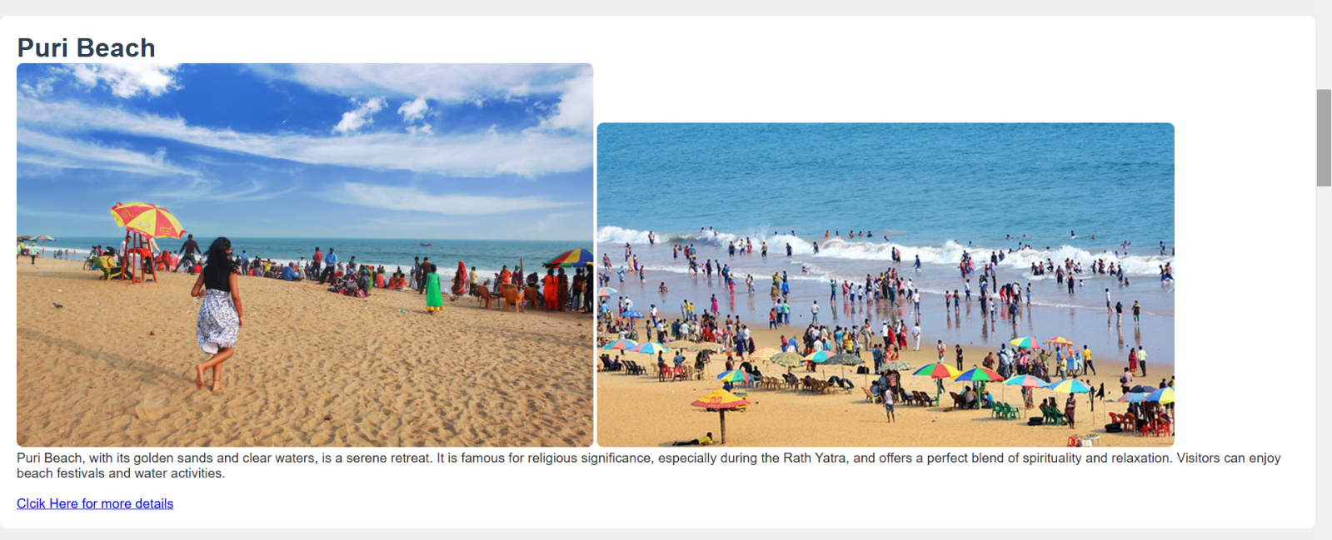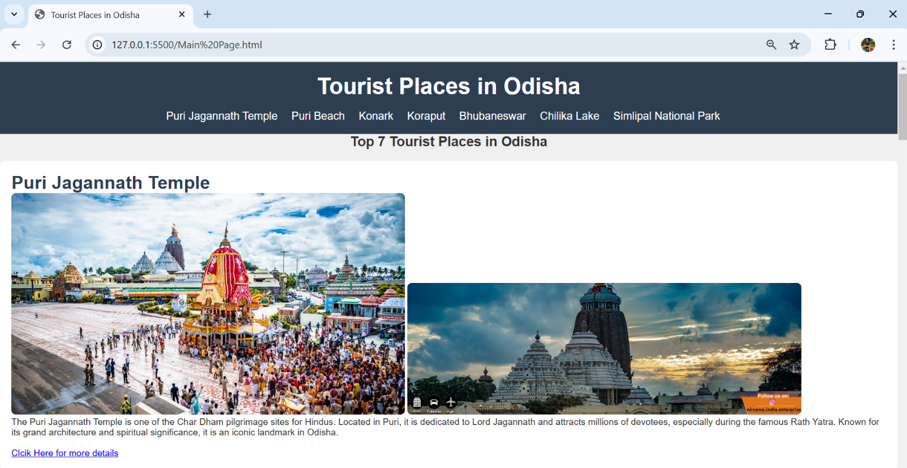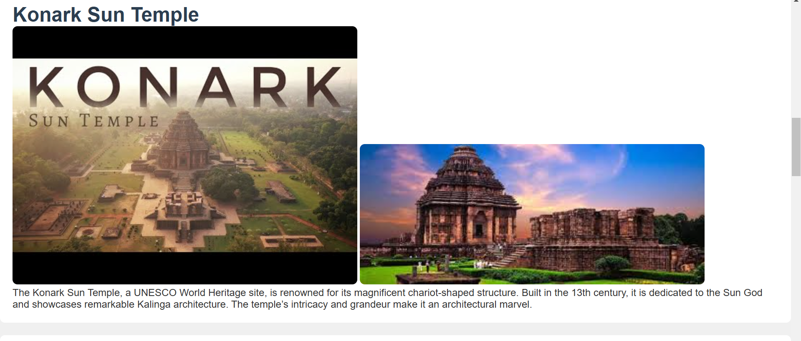Webpage

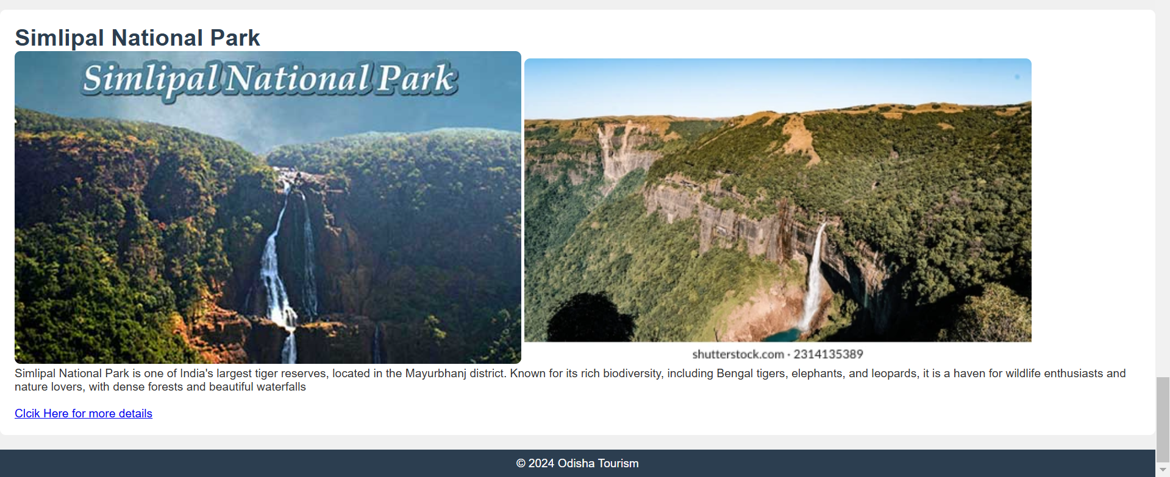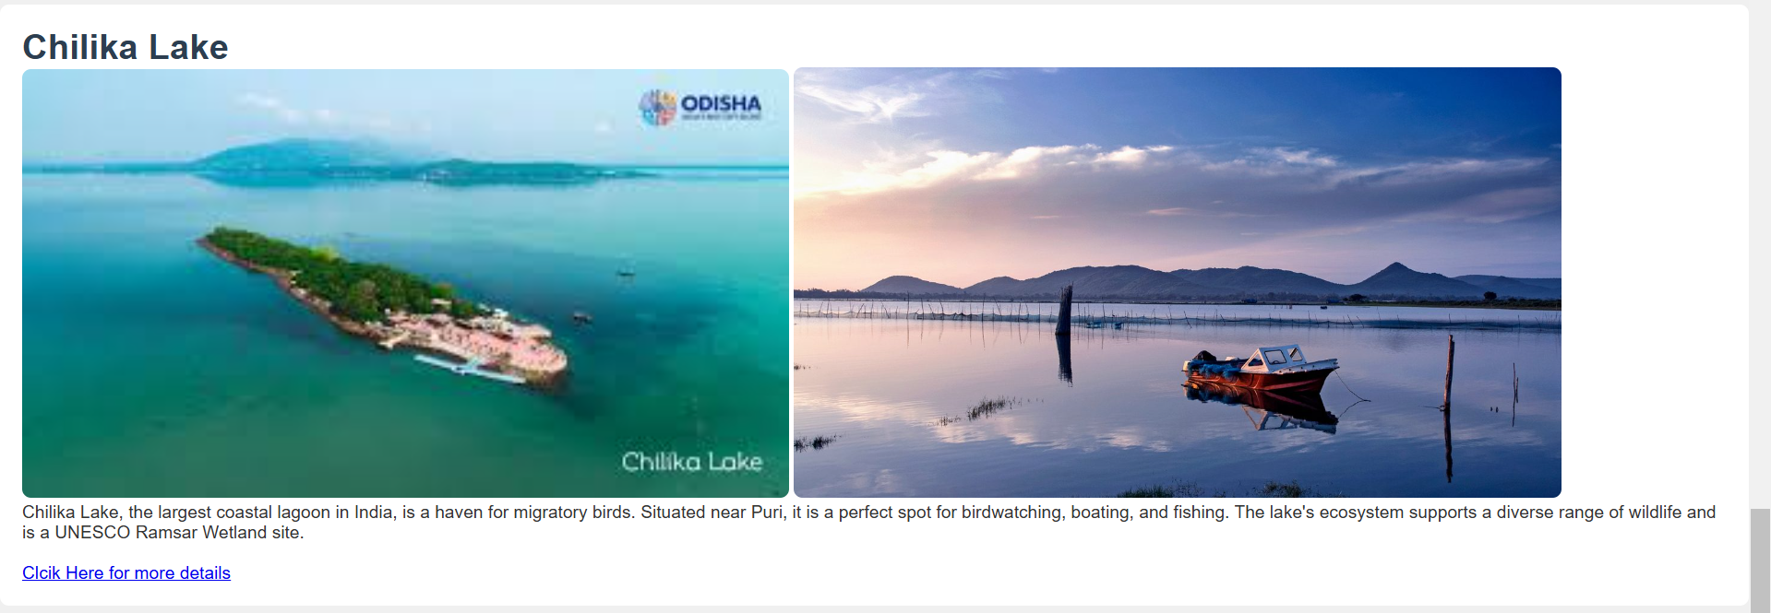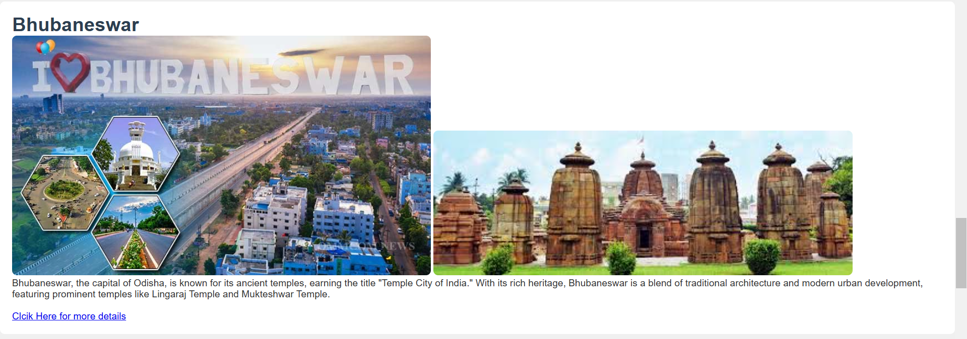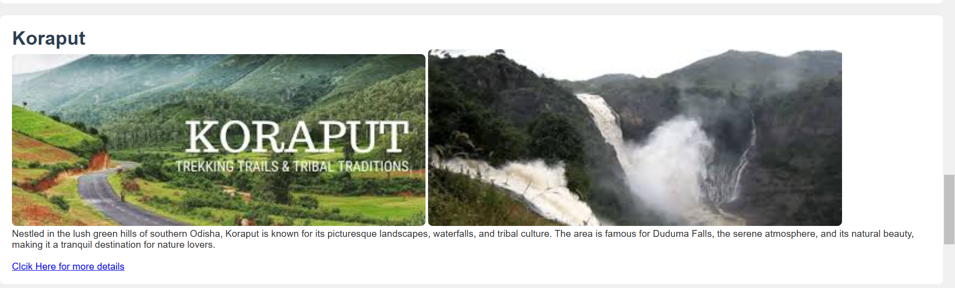

* 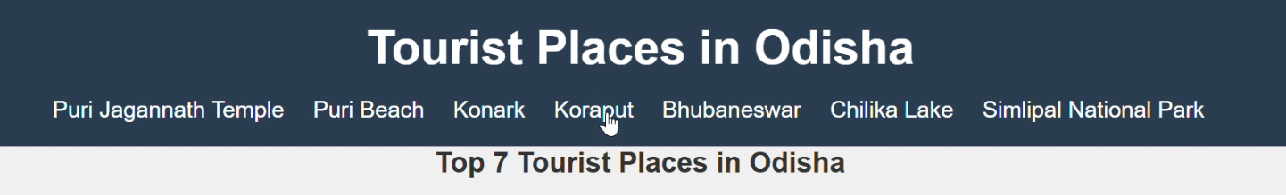JavaScript is used to enable smooth scrolling when a user clicks on a link in the navigation menu.
* The page smoothly scrolls to the relevant section without reloading.

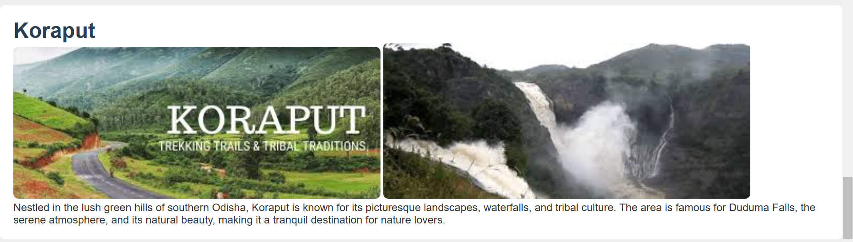

* 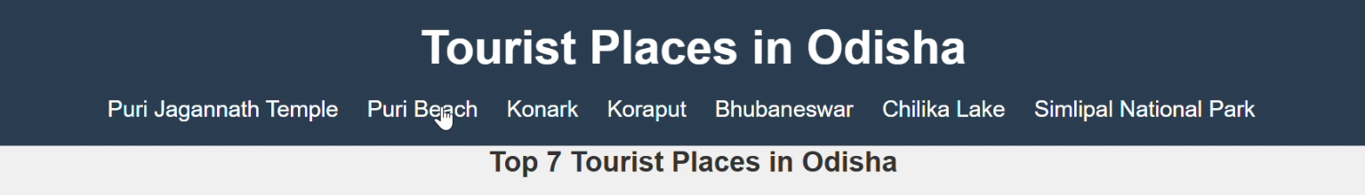JavaScript is used to enable smooth scrolling when a user clicks on a link in the navigation menu.
* The page smoothly scrolls to the relevant section without reloading.

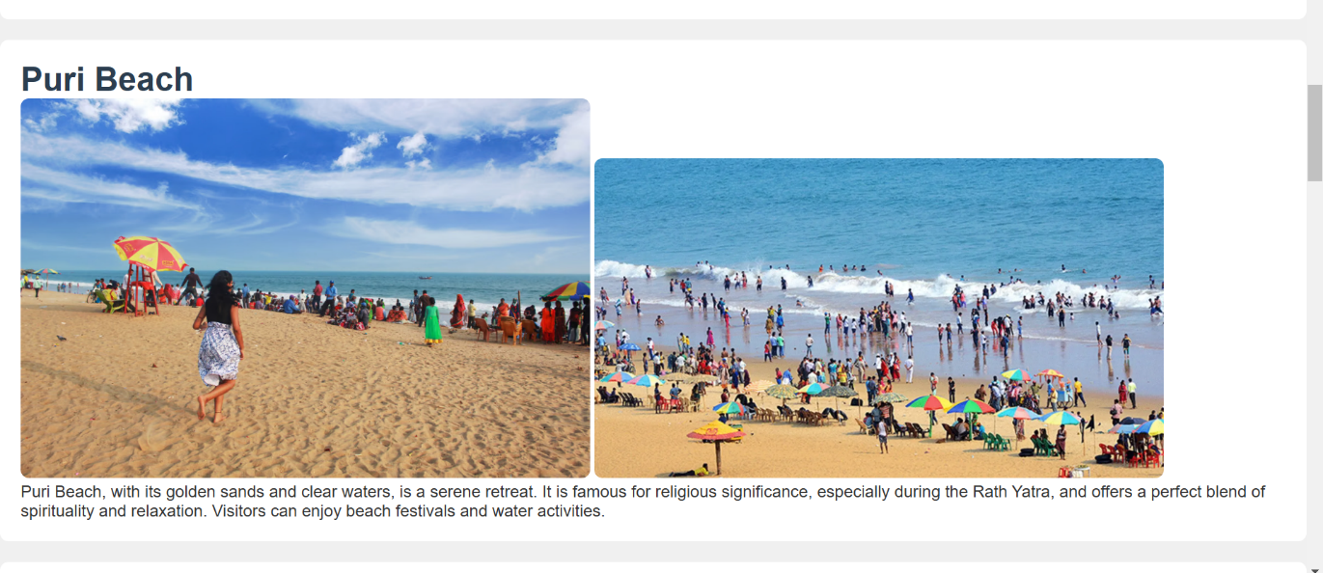

* 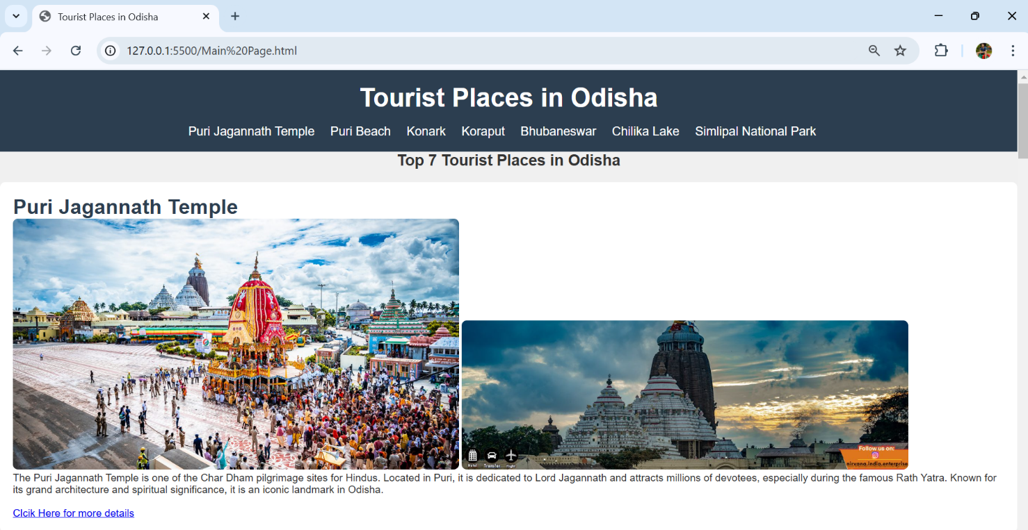We use link to open more about information for all tourist places.
* 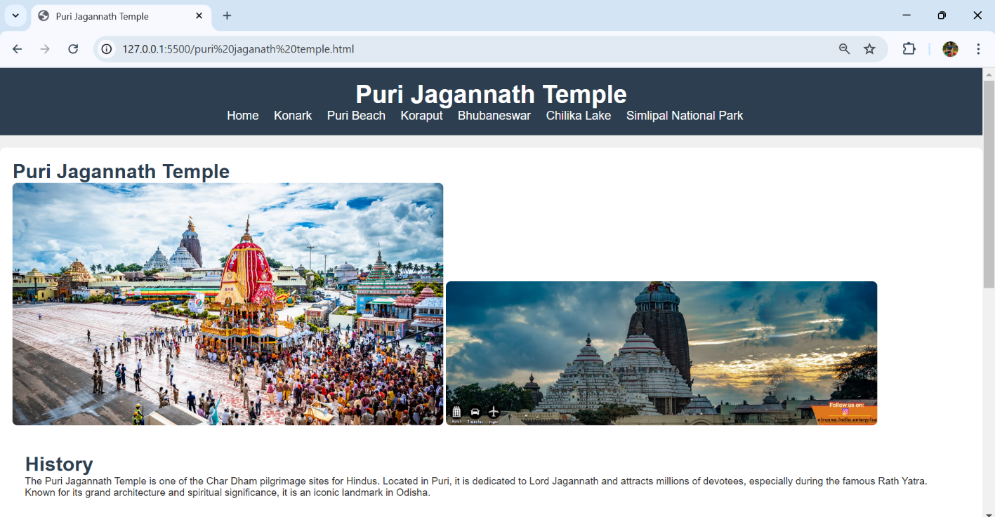Click on the link for open a new page for more information.

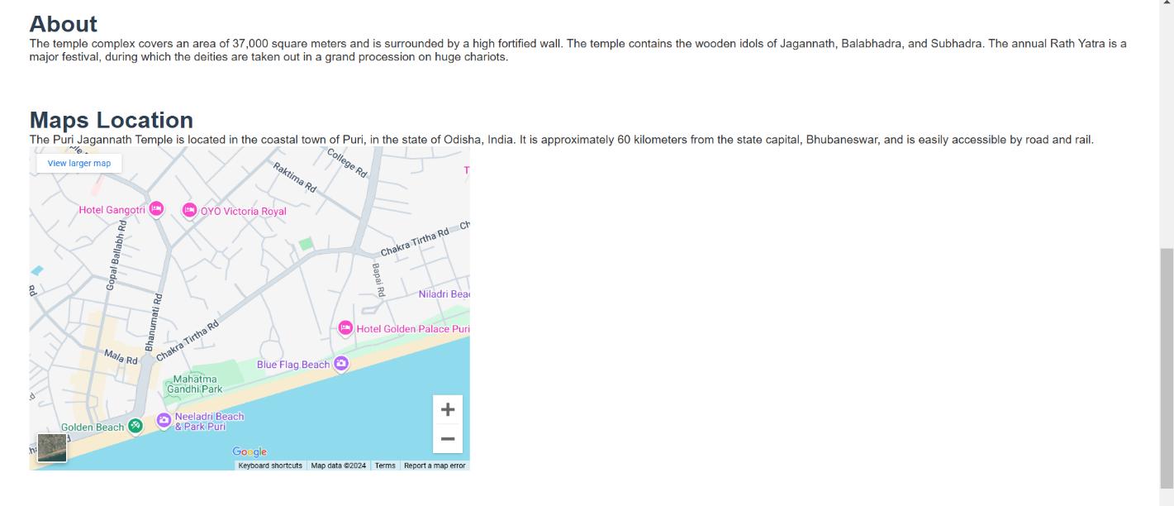

* 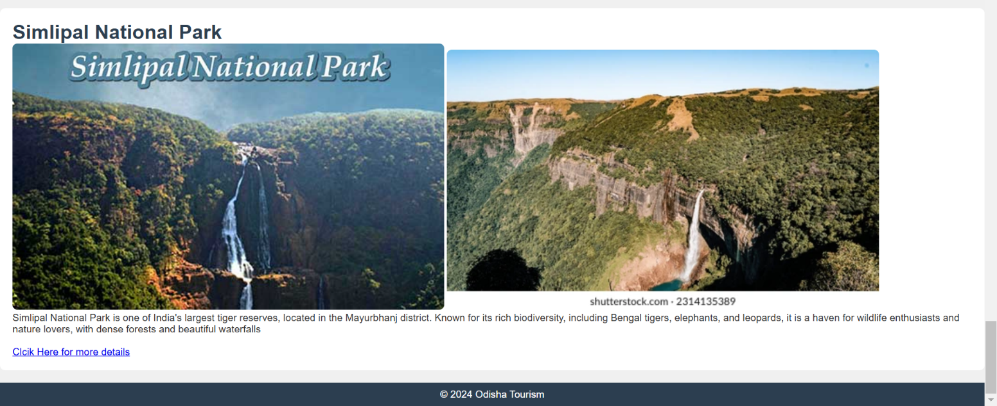Same ,We use link to open more about information for Simlipal National Park.
* Click on the link for open a new page for more information.

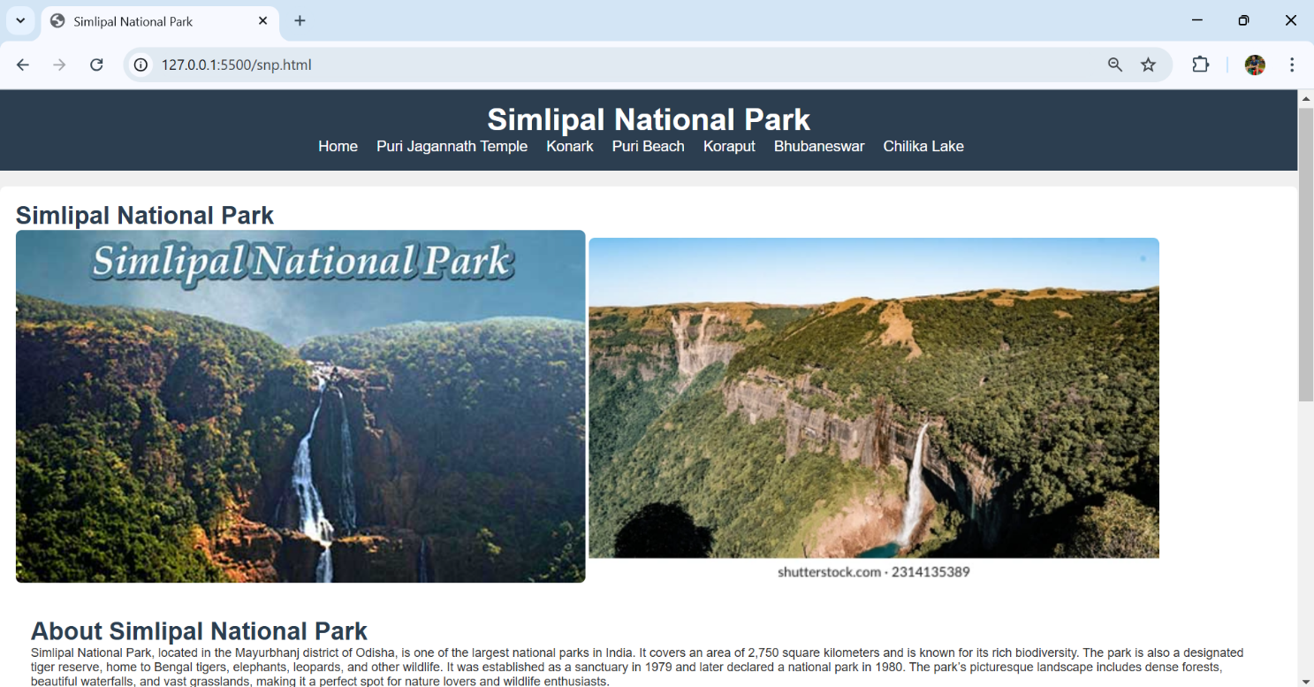

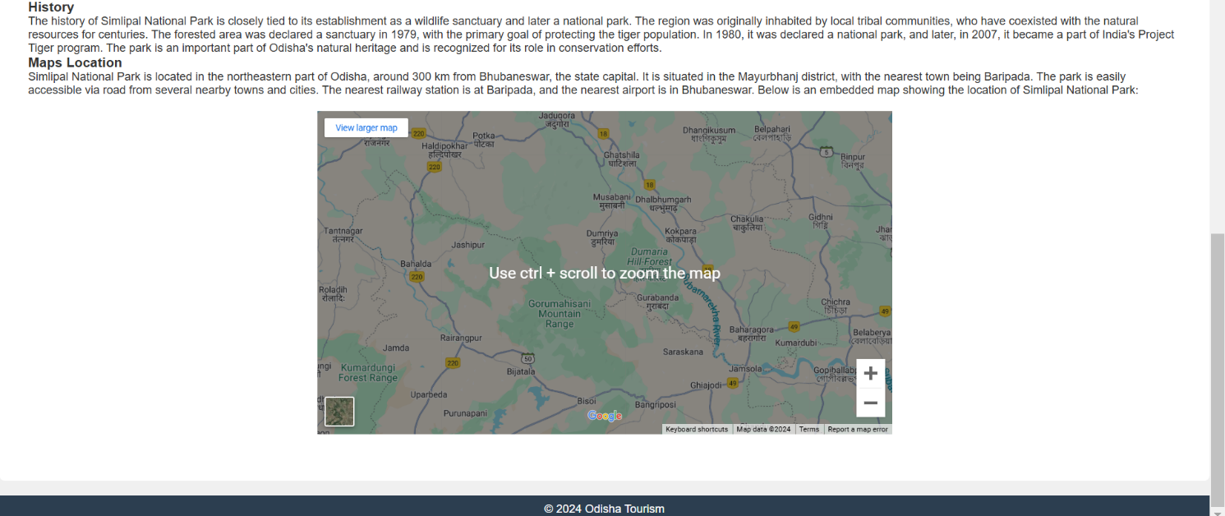

* 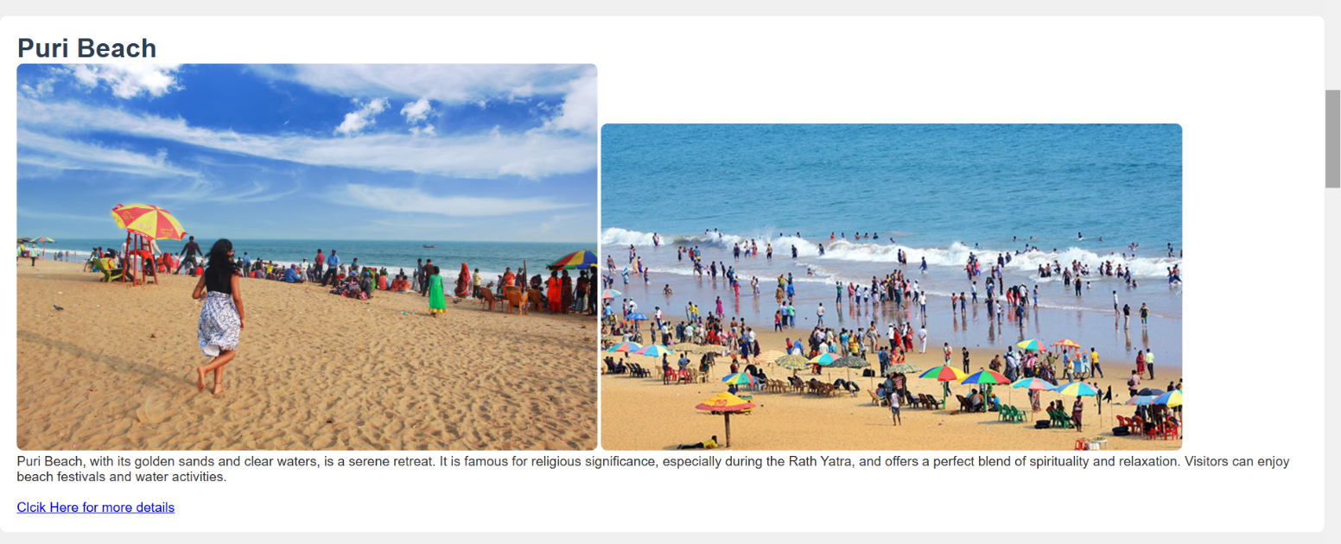Same ,We use link to open more about information for Puri Beach.
* 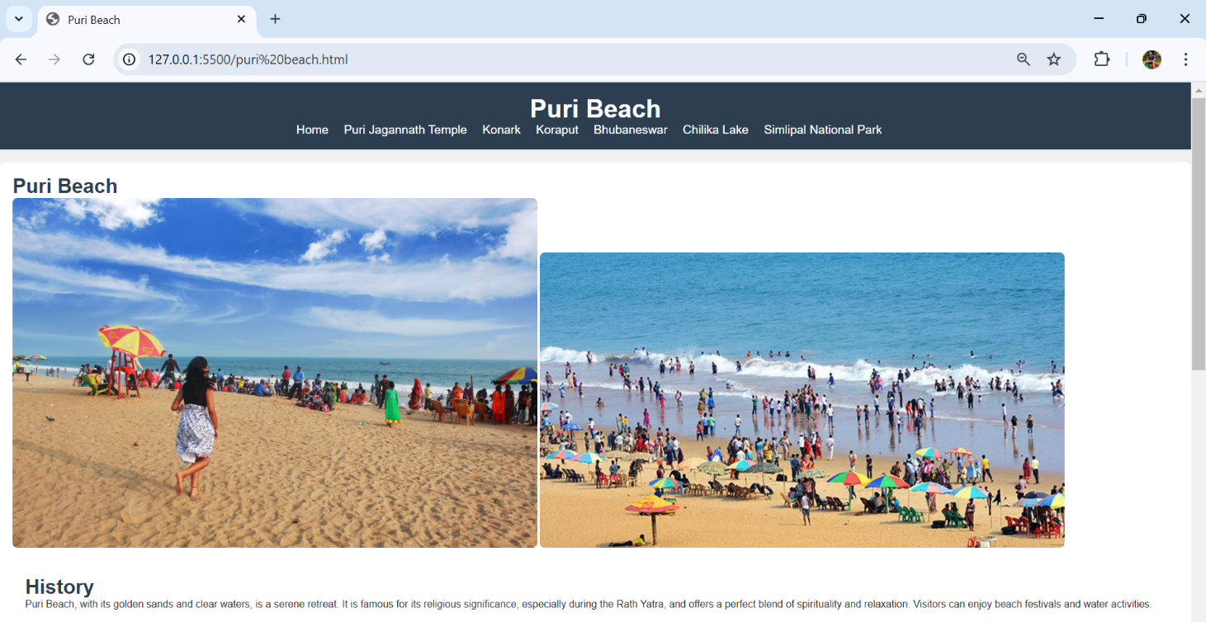Click on the link for open a new page for more information.

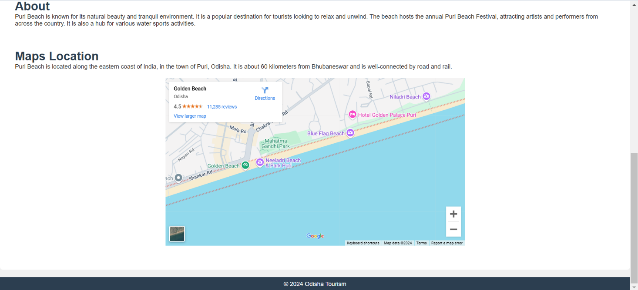

* Same ,We use link to open more about information for Koraput.
* 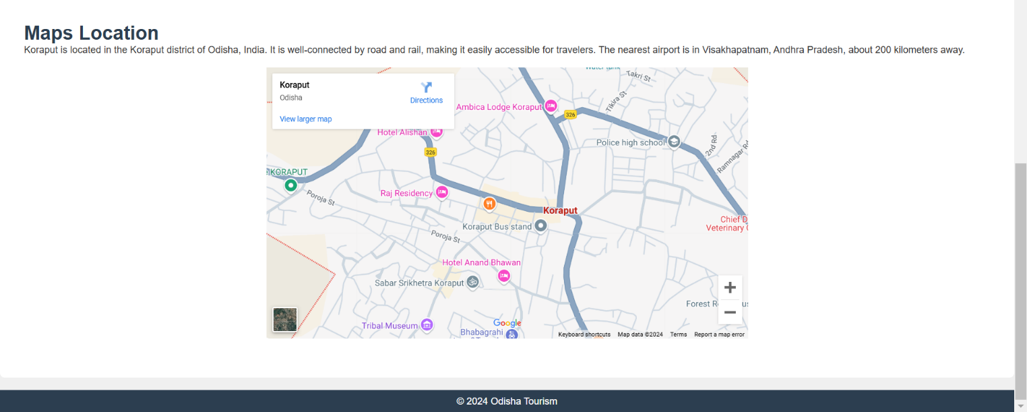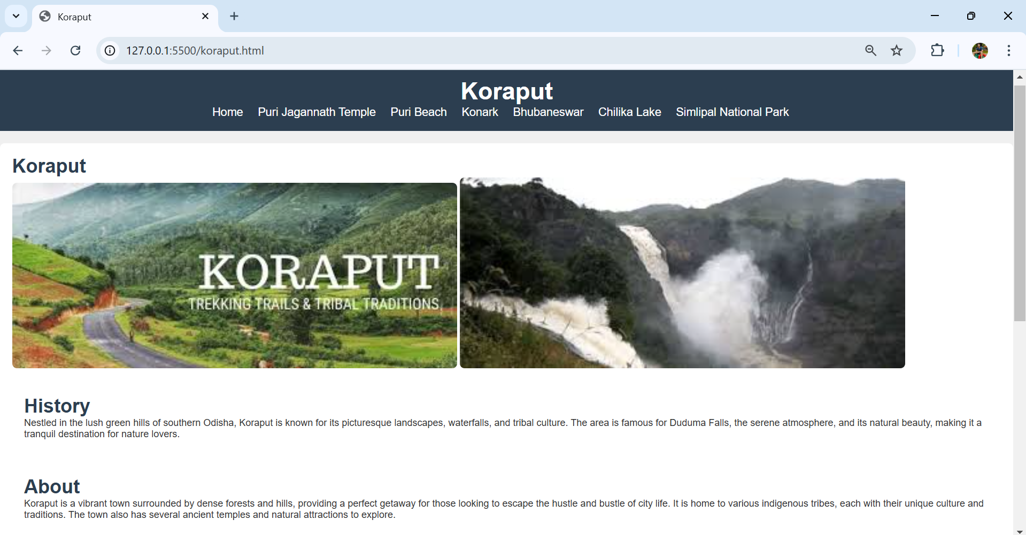Click on the link for open a new page for more information.
* Similarly , We use link to open more about information for all tourist places.

**Conclusion**

The case study on developing a website to showcase the top tourist places in Odisha using HTML, CSS, and JavaScript highlights the powerful synergy between these technologies in creating a dynamic and user-centric platform. By focusing on detailed tourist information, responsive design, and interactive elements, the website successfully captures the essence of Odisha’s rich cultural and natural heritage.

**Key takeaways include:**

1. **Enhanced User Experience**: The use of HTML, CSS, and JavaScript ensures a smooth, engaging, and seamless user experience. The design is optimized for different devices, making it accessible to a broad audience.
2. **Interactivity and Engagement**: JavaScript plays a crucial role in enabling dynamic features such as smooth scrolling, image galleries, and pop-up windows, enhancing user interaction with the content.
3. **Promoting Odisha’s Tourism**: The project contributes to the promotion of Odisha as a prime tourist destination. By providing a visually appealing and informative platform, the website attracts potential visitors, making them more aware of the state’s historical, cultural, and natural landmarks.
4. **Cross-Platform Compatibility**: The responsive and adaptive design ensures that the website functions well across different platforms and screen sizes, maximizing accessibility.
5. **Practical Use of Web Technologies**: This case study illustrates how essential web technologies like HTML for structure, CSS for styling, and JavaScript for interactivity can work together to create a fully functional and engaging website.

In conclusion, the project successfully showcases how web development can be leveraged to promote tourism and provide visitors with an immersive and interactive experience. It serves as a model for future tourism-related websites, emphasizing the importance of using modern web technologies to create engaging digital experiences.

**Future Work**

The current website serves as an effective platform for showcasing Odisha's top tourist destinations. However, there are several avenues for future development to enhance user experience, functionality, and overall impact. Below are some potential future directions for expanding and improving the case study:

1. **Integration of Dynamic Content (Database/Content Management System)**:
   * Future development could involve integrating a backend database or a content management system (CMS) to allow for dynamic updates. This would enable easy addition of new tourist spots, events, festivals, and promotions without requiring code changes.
2. **Virtual Tours and 360° Images**:
   * Implementing virtual tours and 360° images/videos would offer users an immersive experience of the tourist spots. By incorporating technologies such as WebGL or integrating third-party libraries, users could explore locations in virtual reality (VR) mode, increasing engagement.
3. **User Reviews and Ratings**:
   * A user review and rating system could be integrated, allowing visitors to share their experiences of the tourist spots. This feature would encourage user interaction, improve the credibility of the website, and provide valuable insights for potential travelers.
4. **Multilingual Support**:
   * To cater to a global audience, the website could offer multilingual support, especially in major languages like Hindi, Bengali, and English. This would make the website more accessible and user-friendly for people from different regions.
5. **Interactive Maps and Navigation**:
   * Integrating Google Maps or custom interactive maps would help users easily locate tourist spots and explore nearby attractions. Interactive features like route planning and distance calculation could also be added to assist visitors with travel logistics.
6. **Booking and Reservation System**:
   * Incorporating a booking system for accommodations, transportation, and guided tours would offer convenience to users. Integration with online booking platforms could streamline travel arrangements for potential visitors.
7. **Event Calendar and Notifications**:
   * An event calendar feature could display upcoming festivals, cultural events, and special occasions in Odisha. Push notifications or email alerts could be used to notify users about important events, offers, or updates, keeping them engaged.
8. **Social Media Integration**:
   * Allowing users to share their experiences or posts directly to social media platforms like Facebook, Instagram, and Twitter would help promote Odisha tourism. Social media integration could also include live feeds or user-generated content galleries.
9. **SEO and Analytics Optimization**:
   * Improving the website's SEO (Search Engine Optimization) would increase its visibility on search engines, helping more tourists discover it. Additionally, integrating analytics tools would allow website owners to track user behavior and improve the site’s content based on real-time data.
10. **Mobile Application Development**:
    * Developing a mobile application for iOS and Android platforms could complement the website. The app could offer offline access to information, navigation assistance, and personalized suggestions based on user preferences, creating a more convenient and accessible platform.
11. **Sustainability and Eco-Tourism Focus**:
    * Future iterations could focus on eco-tourism and sustainable travel. The website could feature eco-friendly tourist spots, initiatives promoting sustainability, and tips for responsible travel to encourage visitors to adopt eco-conscious practices.

By integrating these features, the website can evolve into a comprehensive tourism platform that not only highlights Odisha's attractions but also offers users a more personalized, convenient, and enriched travel experience. Future work in this direction will enhance user engagement, increase tourism, and make the platform more versatile and dynamic.

**References**

1. **ChatGPT by OpenAI**:
   * OpenAI's ChatGPT provides valuable assistance in creating content and answering queries related to programming and web development.
   * Link: <https://chatgpt.com/share/67549590-43c4-800e-b2c4-b4bc30eb7d4c>
2. **Tourism in Odisha - Official Tourism Website**:
   * This website provides official information on the various tourist destinations in Odisha, along with travel guides and resources.
   * Link: [https://odishatourism.gov.in](https://odishatourism.gov.in/)
3. **Google Maps - Tourist Locations in Odisha**:
   * Google Maps can be a great tool for integrating interactive maps to showcase tourist destinations in Odisha.
   * Link: [https://maps.google.com](https://maps.google.com/)
4. **W3Schools - HTML, CSS, and JavaScript Tutorials**:
   * W3Schools offers a comprehensive range of tutorials and examples on HTML, CSS, and JavaScript, which can help you enhance the technical aspects of the website.
   * Link: [https://www.w3schools.com](https://www.w3schools.com/)
5. **MDN Web Docs - Mozilla Developer Network**:
   * MDN provides in-depth documentation on web technologies such as HTML, CSS, and JavaScript, which is useful for building your tourism website.
   * Link: [https://developer.mozilla.org](https://developer.mozilla.org/)